National University of Computer & Emerging Sciences Karachi Campus


GAMING ZONE SYSTEM
Project Report
Object-Oriented Programming
Section: 2J

Group Members:
23k-0696 Muhammad Shayan Faisal
23k-636 Hamza Ahmed
23k-0789 Muhammad Sufyan Ali

Project Report
- Title: Advanced Gaming Zone (Snake Game, Tic Tac Toe)
- Introduction
The aim of creating a new advanced gaming zone is to inform the user about the new advanced level in snake game and tic tac toe game which opens a challenging mode for everyone. It provides the user a new interface in which they can play in their free time.
- Background (Research and Project Selection)
The selection of this project is completed by the research in other games, where snake game and tic tac toe found no such details so snake game and tic tac toe becomes a superior decision to us. In the completion of this project, the necessary assistance met from w3 resource where the overview and the function are used to complete it. Additionally, all are aware of these games in their childhood.
- Project Specification:
The time required to complete the project is distributed by our group partners equally by separating functions in code. Snake game has the feature of time limits and walls as obstacles. It has the functionality to create a bit of difficulty in a snake game. It has the features of making 2 by 2 length width where snakes can travel in it. The snake will circulate in the box.it will proceed to right, left, up and down directions. The snake needs user instructions to move. Where Tic tac toe game masters in creating difficulty level of turn by computer’s choice to create the bit difficulty.
- Problem Analysis:
Moreover, basic games are entertaining, but once a player plays them, they may become repetitive, predictable and lack a competitive aspect. They tend to be long, time wasting, thus making the game boring. These problems can be improved by adding a couple of new features to the game and its design.

- Solution Design (Project Detail, Functionality and Features):
Snake game has the features of hurdles in it where the user by its own method of instruction tends to reach the food in time to win. However, the snake is represented in this project by a small square, the fruit is represented by ‘F’. The snake that is present in this game is at center and food is present at different locations at different times by using random functions rand().The game has the other features as well such as difficulty level in moving the snake from center to food to get finished on time. 4 separate functions have been used to complete this snake game project, one for sketching, second one for input from the user, third one is movement of fruit, fourth one is for position of obstacles, where as in Tic tac toe time player turn has been represented by ‘X’ and computer turn has been represented by ‘O’, time factor has also been the part of this game to make it tough and competitive. Drawboard() , input player and computer , logic player and computer have been the major functions for building the concept of tic tac toe.
- Implementation and Testing
It has the power of creating mindful use in testing the game to pass the snake from its initial position to desired position and in tic tac toe the logic building takes a lot of time. However, this project is tested on dev c++ where it was started. It contains lots of errors in the beginning after testing and resorting to get the desired output.
- Project Breakdown Structure (Workload Distribution with Timeline)
The project required hardly one week in 3 to 4 hours in a day to get the desired result. However, the project is distributed in a couple of functions to the partners to get work load distributed.
- Results(Outputs Screen Shots):
The tic tac toe game also has a timer in it for the player’s turn.
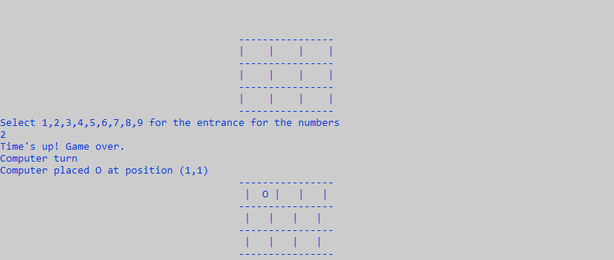
It also has timer of 10 about which make it complex to win.
See computer win
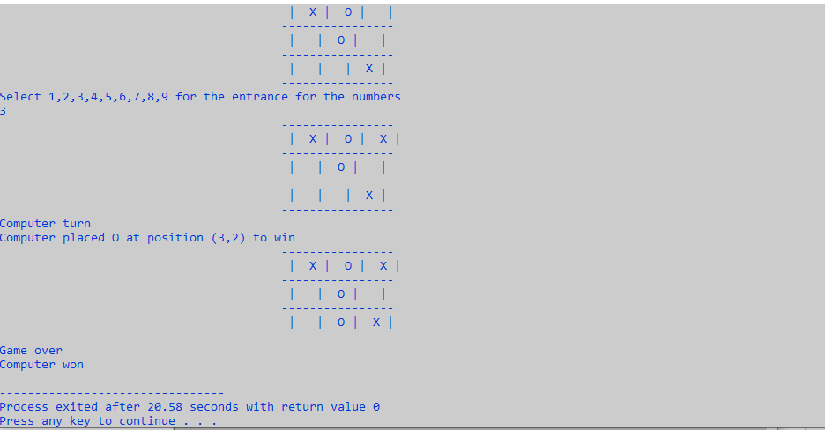
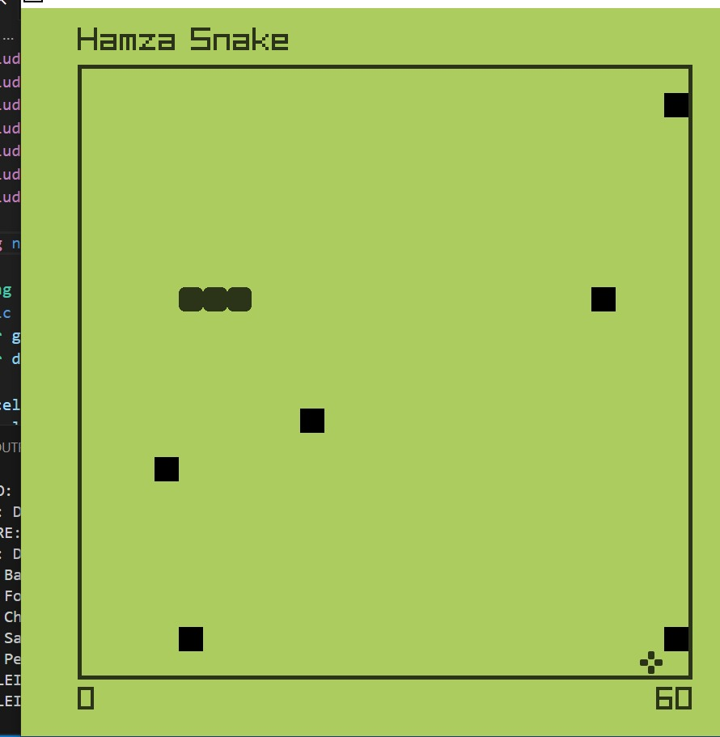
- Conclusion (Summary and Discussion)
As mentioned, all the requirements are met which stated in the proposal. As project makers highly recommend this game to be used in future for gaming. All of its features are discussed, so we hope that this game gains such high popularity.

